Watch Terraform-04 video.
Execute the script shown in the video.
Use specific version
Go to terraform registry and use provider
terraform {
required_providers {
local = {
source = "hashicorp/local"
version = "2.5.2"
}
}
}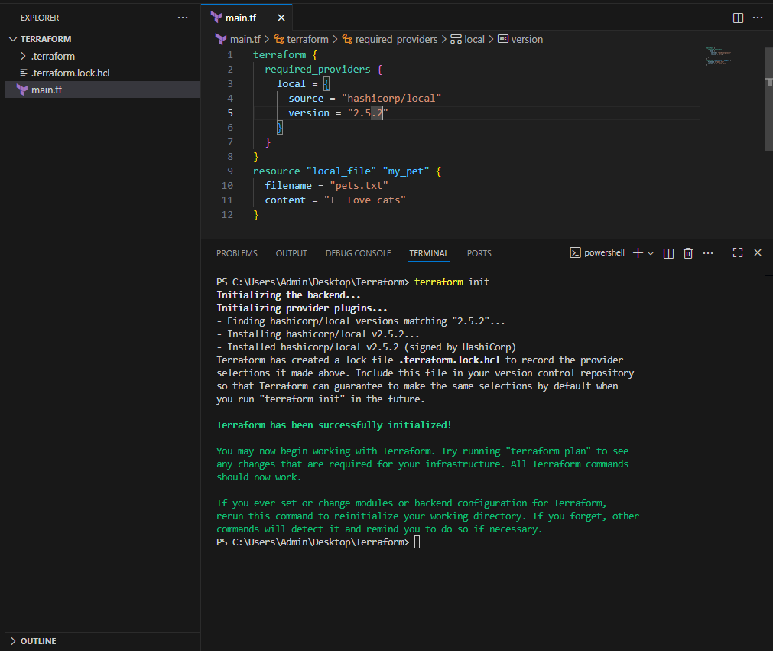
We can restrict our providers which version need to download
Version = “2.5.1” download the exact version
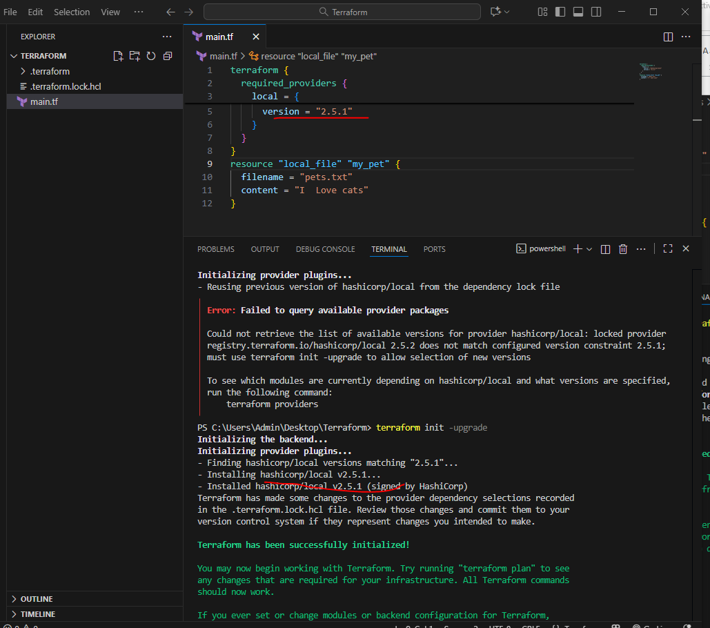
Version =”2.5.1” will not use the mentioned version
Version should not equal to 2.5.1 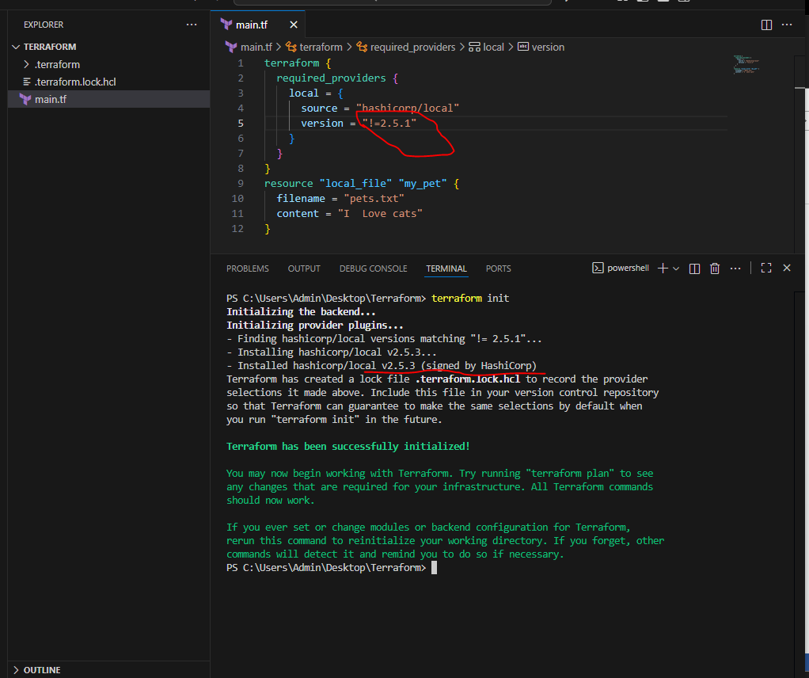
Version =”2.5.1” lesses than the mention version
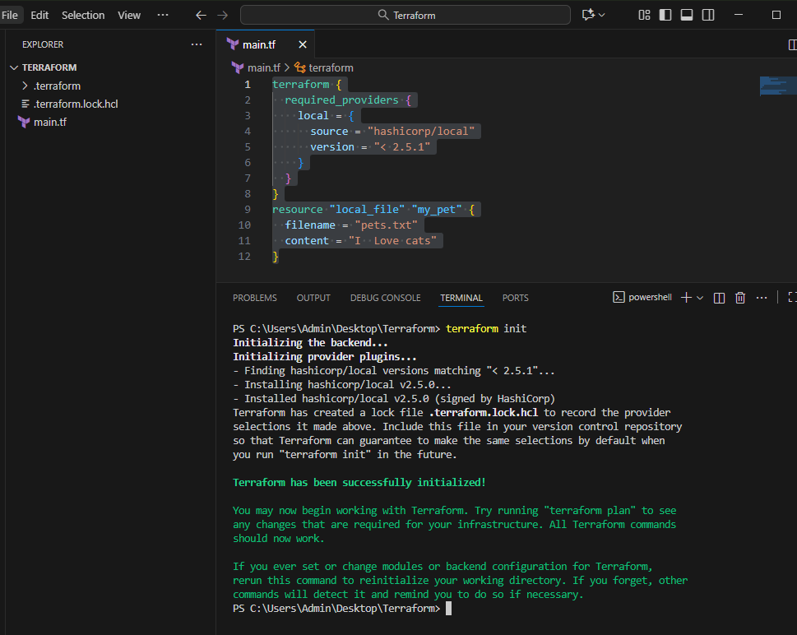
Version =”2.5.1” greater than the mention version
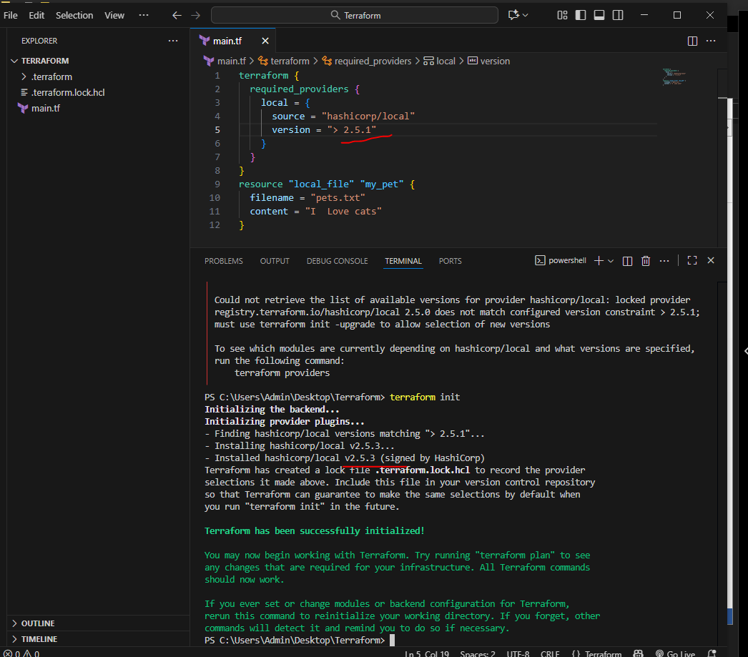
Version =”2.5.1” specific version or higher version
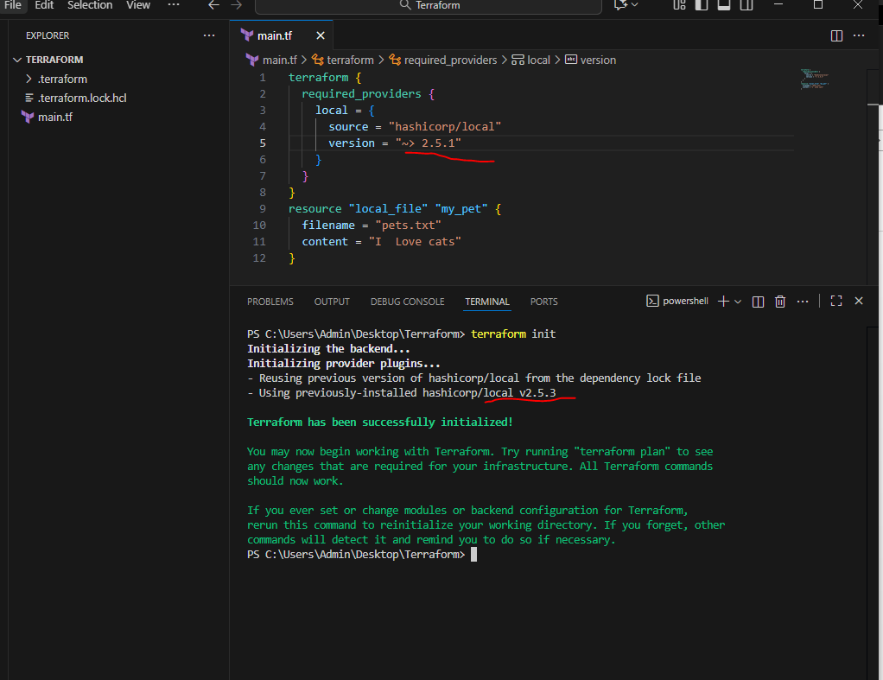
Data Sources
Data sources is used to read content of the infrastructure.
We have to create new file name it animals.txt {I love animals}
Resource “local_filename” “my_pet”
Filename = “pets.txs”
Content = data.local_file.animal.content
}
Data “local_file” “animal”{
Filename = animals.txt”
}
Then terraform apply

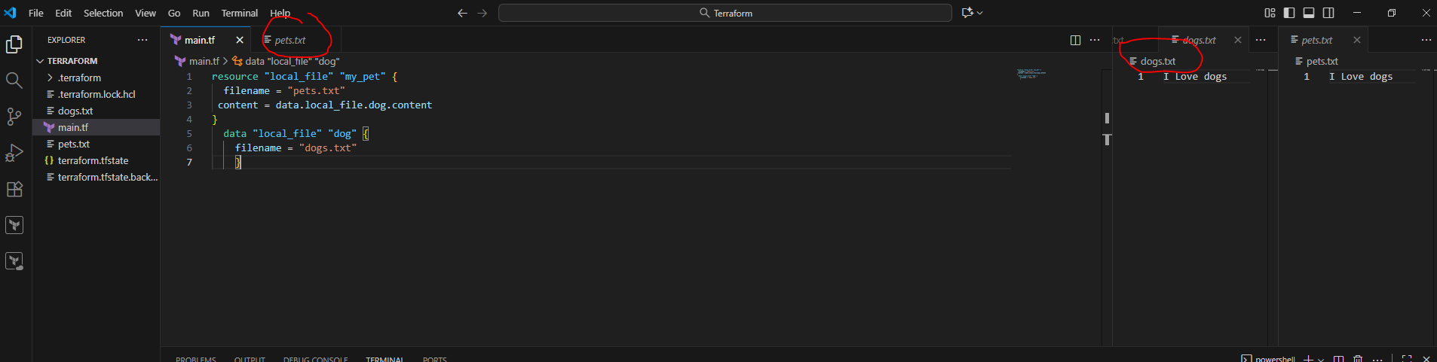
Meta Arguments
Meta arguments are used to create multiple files.
Meta arguments can be used within any resource block
1)depends_on
2)lifecycle
3)count
4)For_each
Count: If we want to create multiple files we will use count
It based on index number

Main.tf
Resource “local_file” “my_pet” {
Filename = var.filename[count.index]
Content = length(var.filename)
}
Variable.tf
Variable “filename” {
Default =[
“pets.txt”,
“cats.txt”,
“animal.txt”
]
}
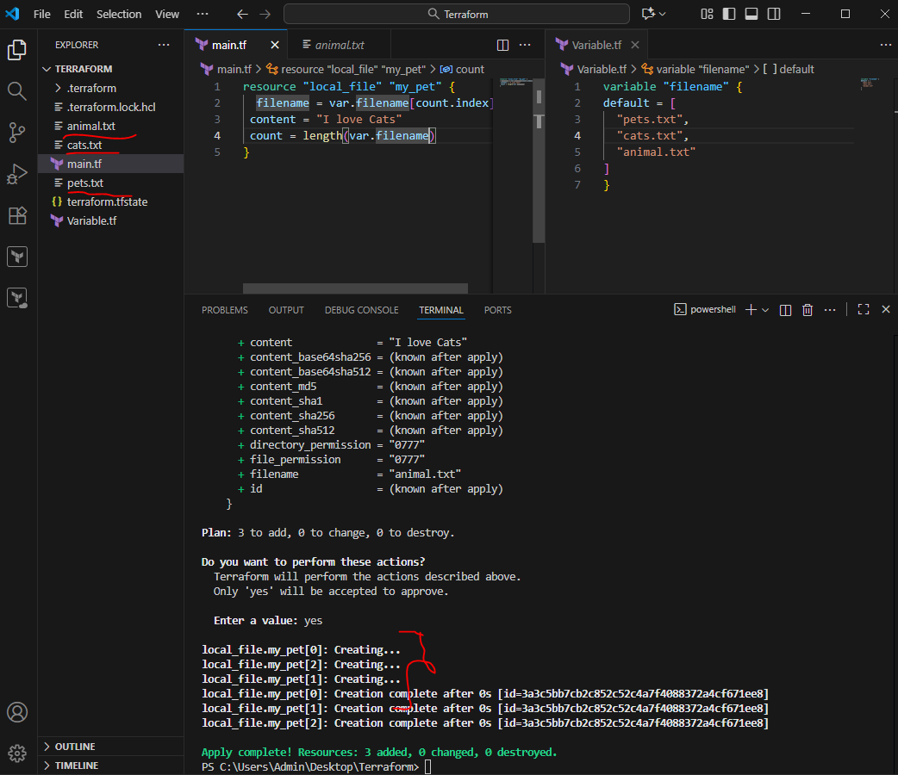
For_each

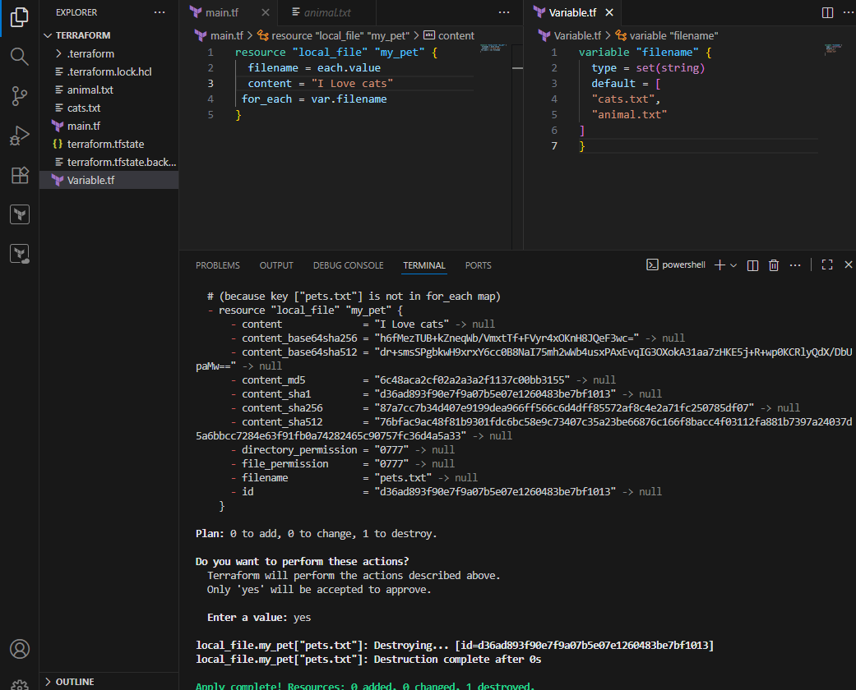
AWS Service with terraform
Lets login in AWS account
Configure with AWS (credentials)
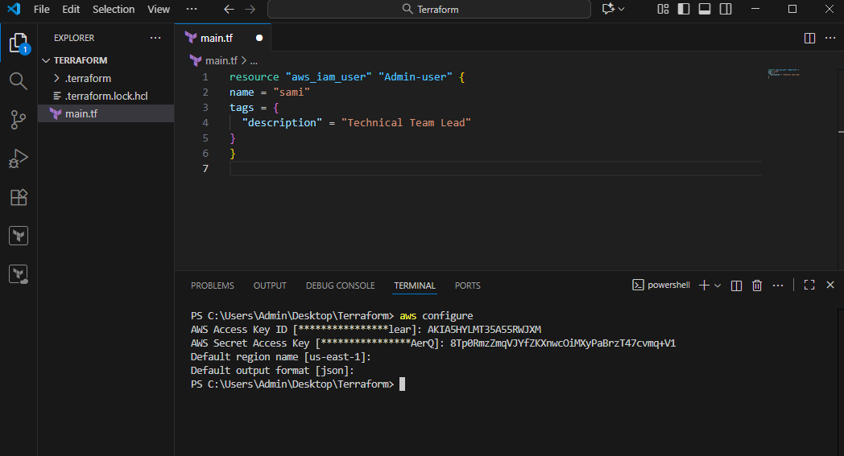
Create Iam user
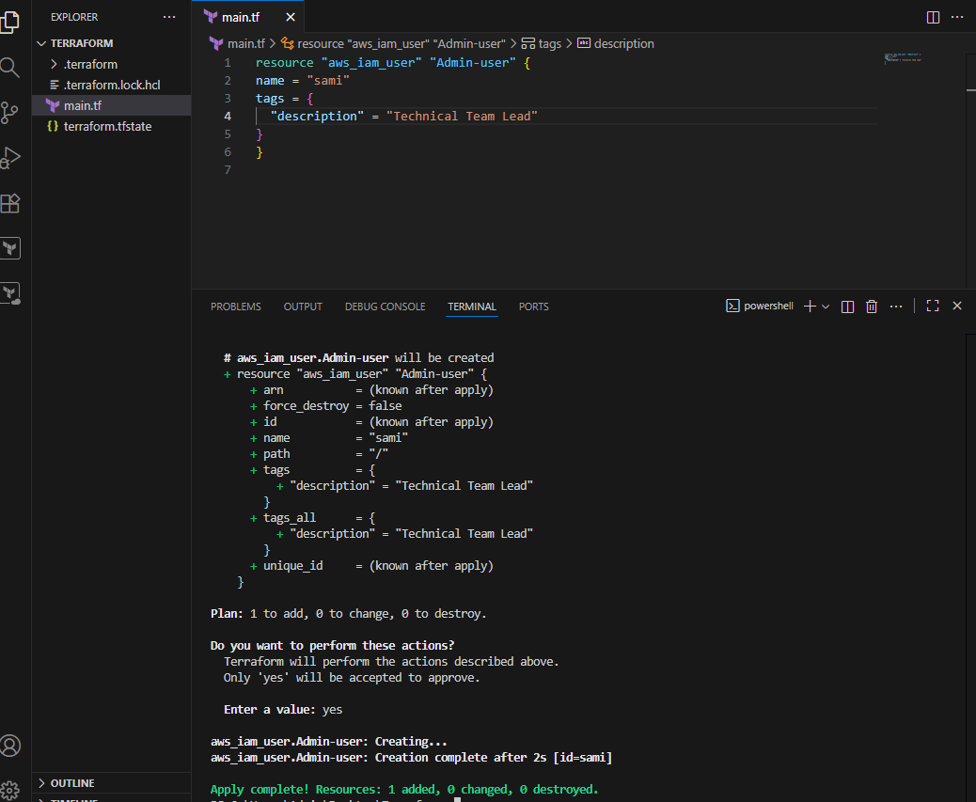
Created IAM user
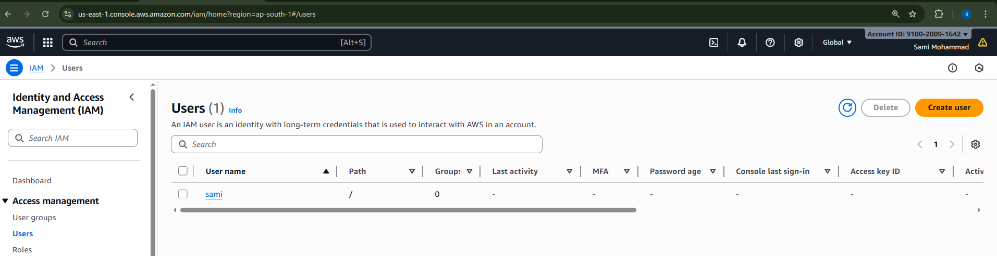create an admin policy attach to sami
Heredoc syntax
<<EOF
{
"Version": "2012-10-17",
"Statement": [
{
"Sid": "1234567890",
"Effect": "Allow",
"Action": "*"
"Resouce": "*"
}
]
}
EOF
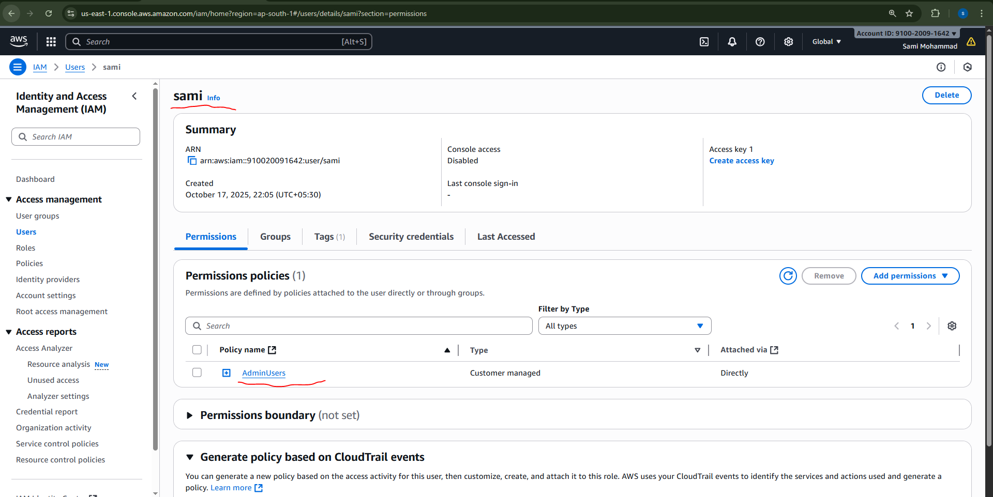
3 Integrate Terraform in Jenkins using the Terraform plugin.
Step 1: Install Terraform on Jenkins Server
On the Jenkins machine (EC2, VM, etc.):
# Install Terraform
wget
https://releases.hashicorp.com/terraform/1.8.5/terraform_1.8.5_linux_amd64.zip
unzip terraform_1.8.5_linux_amd64.zip
sudo mv terraform /usr/local/bin/
terraform –version
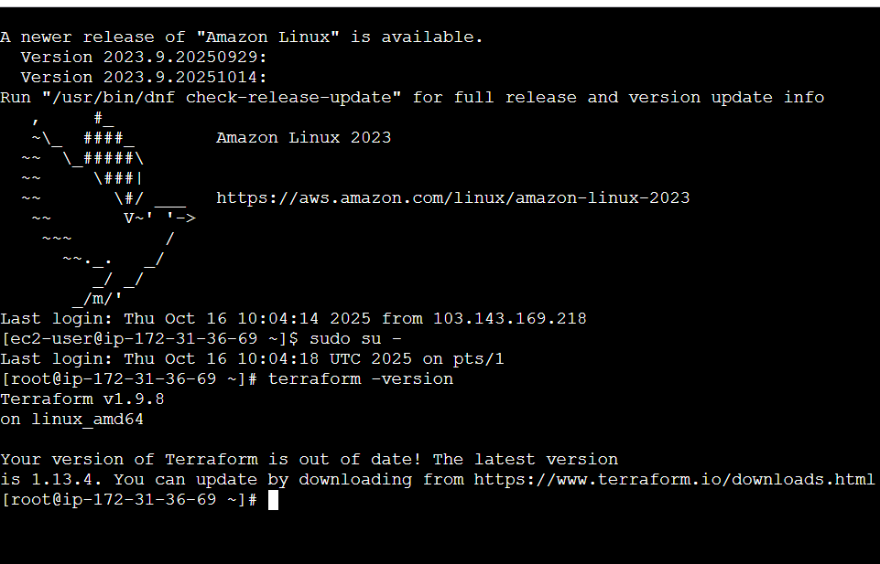
Step 2
Go to Jenkins Manage Jenkins Install Terraform plugins
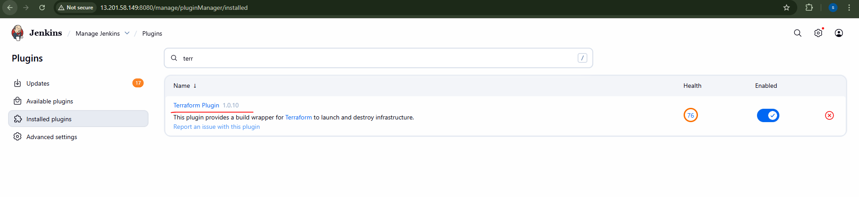
Configure Terraform in Jenkins
Go to Manage Jenkins toolsTerraform
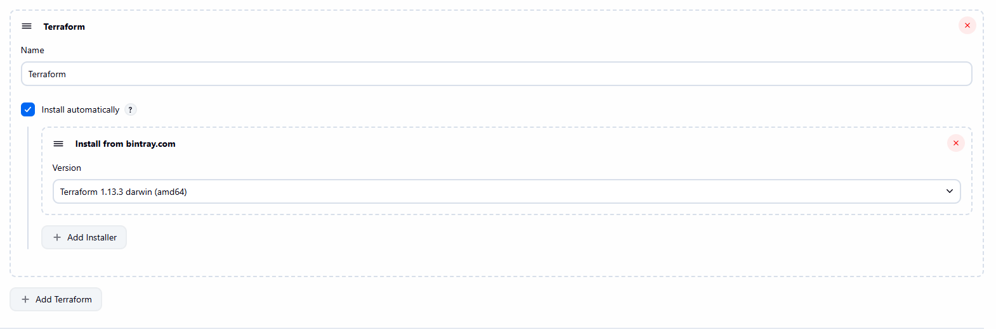
Go to github
Main.tf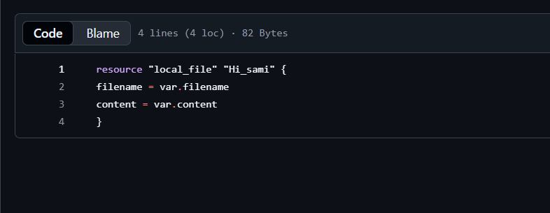
Variable.tf
Jenkisfile
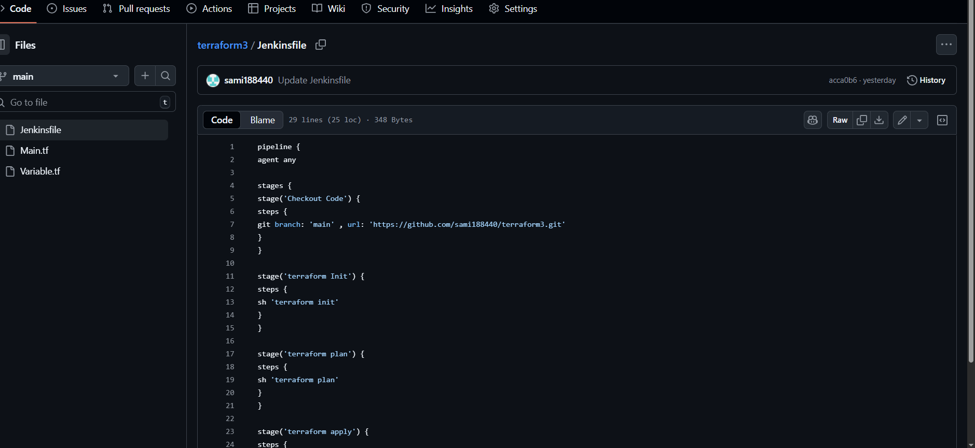
Save and buildnow
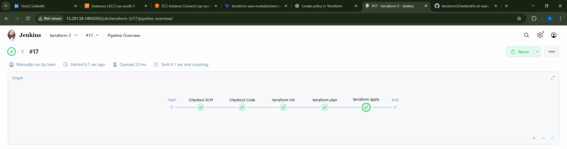

4 Create a CI/CD pipeline for a Nodejs Application: https://github.com/betawins/Trading-UI.git
Set Up Jenkins
1. Install required plugins:
NodeJS plugin (to install Node.js runtime)
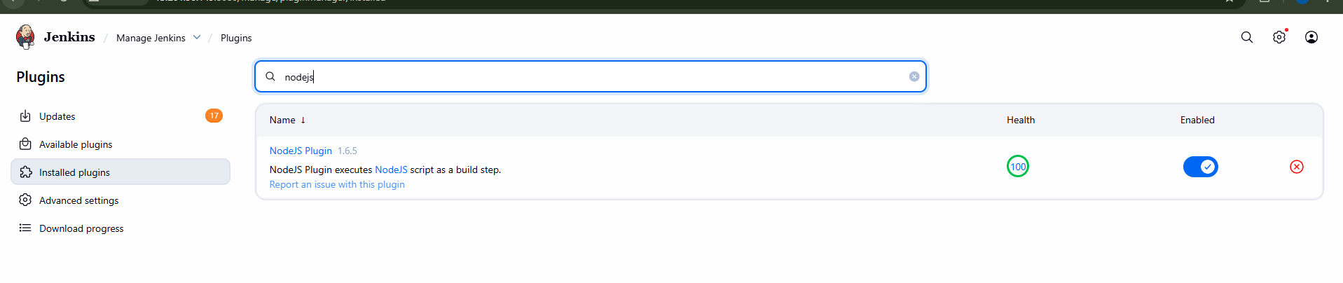
Configure NodeJS Tool in Jenkins:
Go to Manage Jenkins → Global Tool
Configuration → NodeJS installations (keep the name nodejs16)
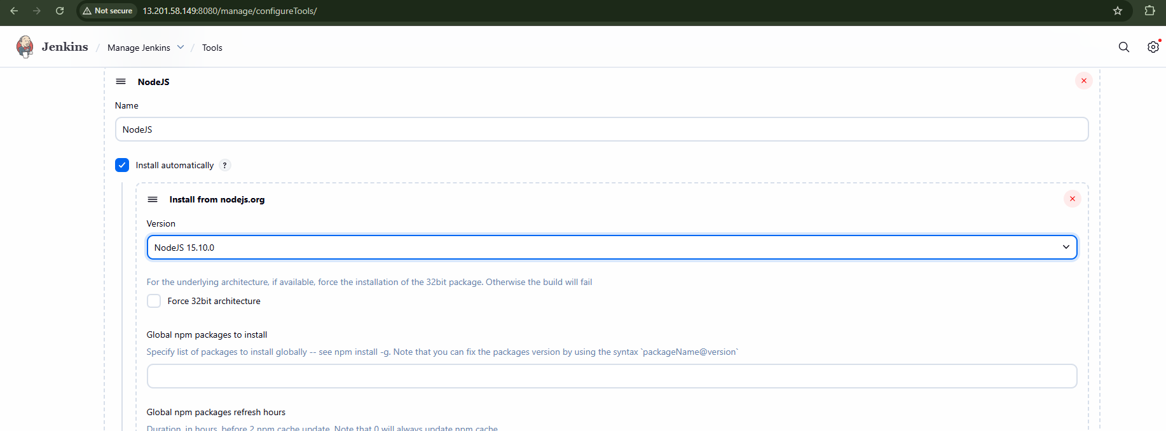

Fork the github repo of the url
. Create Jenkinsfile in GitHub Repo
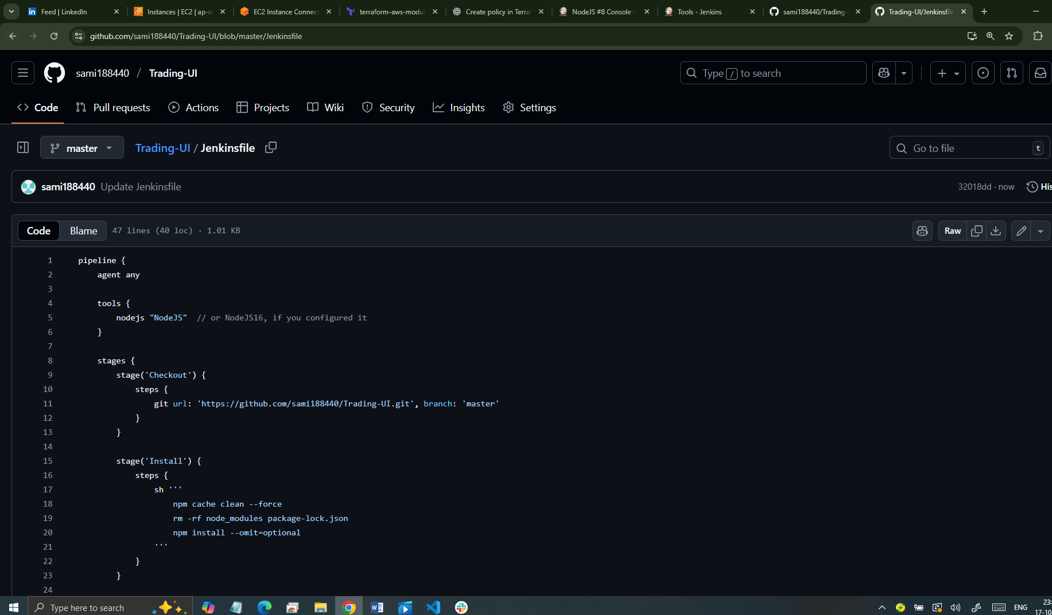

Create a Jenkins Pipeline Job:
o New Item → Pipeline → Name it → Select "Pipeline from SCM"
o Choose Git and provide repo URL
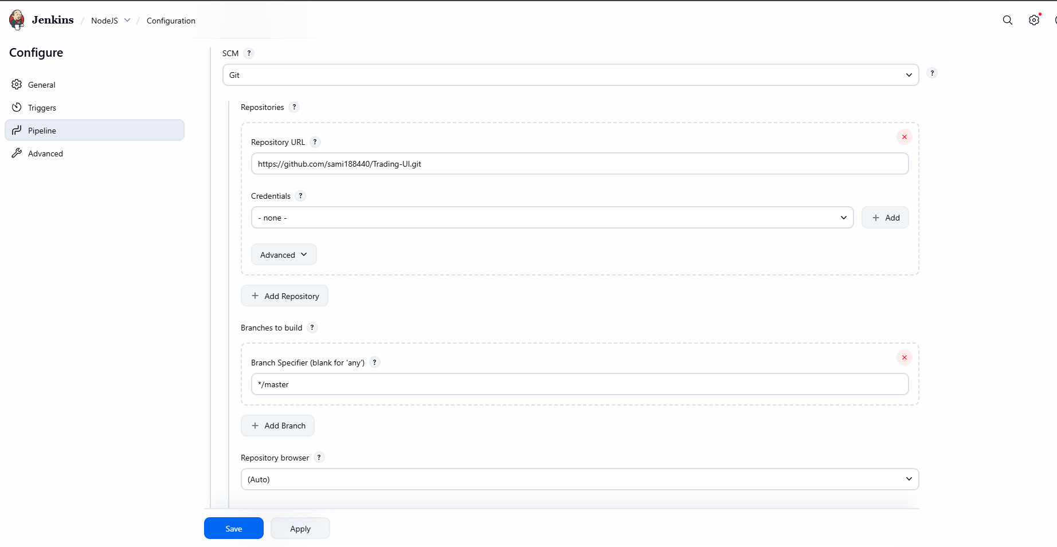
Save and buildnow
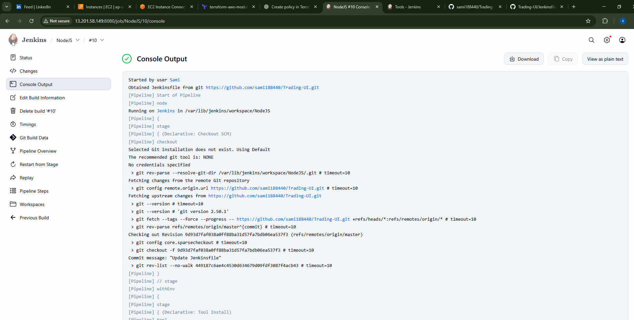
5Explain 10 Maven commands.
1.mvn clean
Removes the target/ directory (where compiled files,
packaged JARs/WARs, etc. are stored).
Ensures you start with a clean build environment.
Cmnd : mvn clean
2. mvn compile
Compiles the source code of the project (from src/main/java).
Output goes to target/classes.
mvn compile
3. mvn test
Compiles and runs the unit tests (in src/test/java) using
JUnit/TestNG.
mvn test
4. mvn package
Packages the compiled code into a JAR/WAR file as defined in
pom.xml.
Example: target/my-app-1.0-SNAPSHOT.jar
mvn package
5. mvn install
•Installs the packaged project into the local Maven repository
(~/.m2/repository).
Makes the artifact available for use in other local projects.
mvn install
6. mvn deploy
Copies the packaged code to a remote repository (like Nexus,
Artifactory).
Used in CI/CD pipelines for sharing artifacts with other
developers.
mvn deploy
7. mvn site
Generates a site documentation (reports, dependencies,
plugins
info, etc.) for the project in target/site.
mvn site
8. mvn dependency:tree
Shows the dependency hierarchy of the project.
Useful for identifying conflicts between library versions.
mvn dependency:tree
9. mvn validate
Validates the project’s structure and checks if pom.xml is
correct.
Runs before compilation.
mvn validate
10. mvn verify
Runs any integration tests and checks if the package is valid.
Ensures the project is ready for deployment.
mvn verify
Summary:
Command Purpose
mvn clean Remove target/ build files
mvn compile Compile source code
mvn test Run unit tests
mvn package Package into JAR/WAR
mvn install Install into local repo
mvn deploy Deploy to remote repo
mvn site Generate project site reports
mvn dependency:tree Show dependency tree
mvn validate Validate project structure
mvn verify Run integration tests & verify package

